HOW TO MAKE A STUDENT FROM PROVISIONAL ADMISSION TO ADMITTED AND UPDATE ROLL NO., CLASS AND BATCH

Step 1. Go to Course Enrollment Screen and select a student

Step 2. Go to ‘is Provisional Admission’ field and select ‘No’ in the dropdown

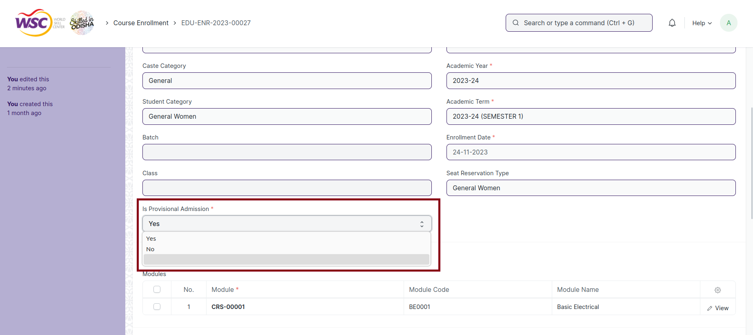

Step 2. Goto ‘Admission Status’ field and select ‘Admitted’ in the dropdown

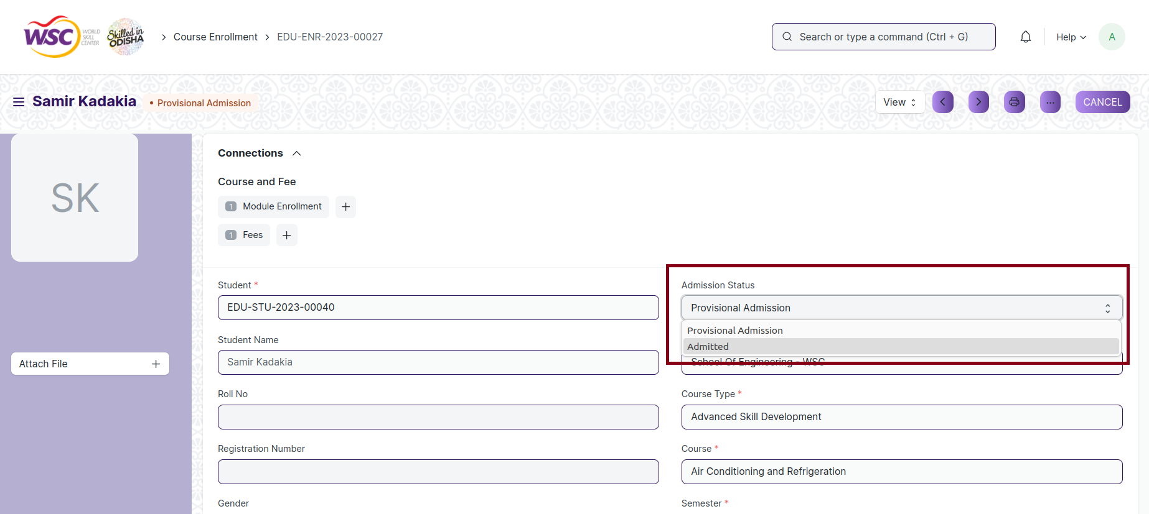

Step 3. Update/Add Roll No. in the Roll No. field

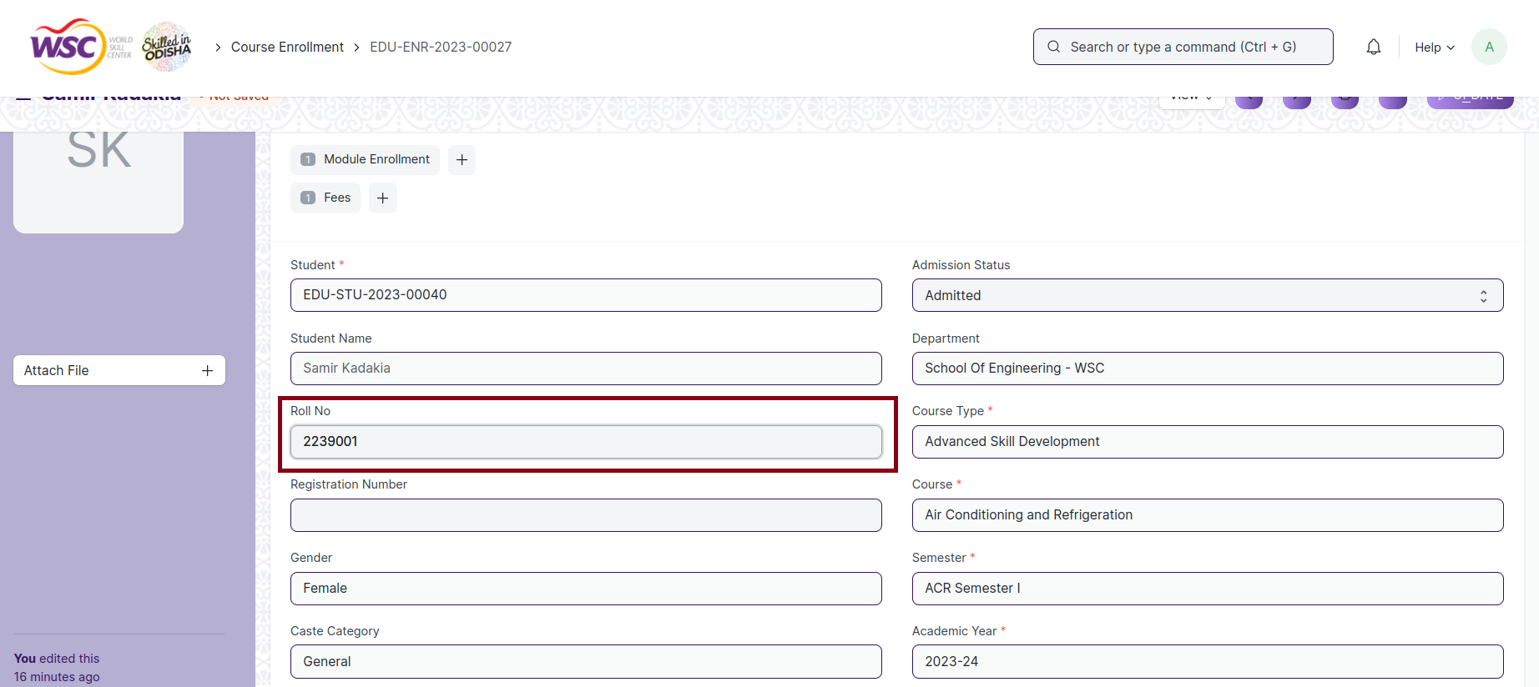

Step 4. Update/Add Class in the Class field

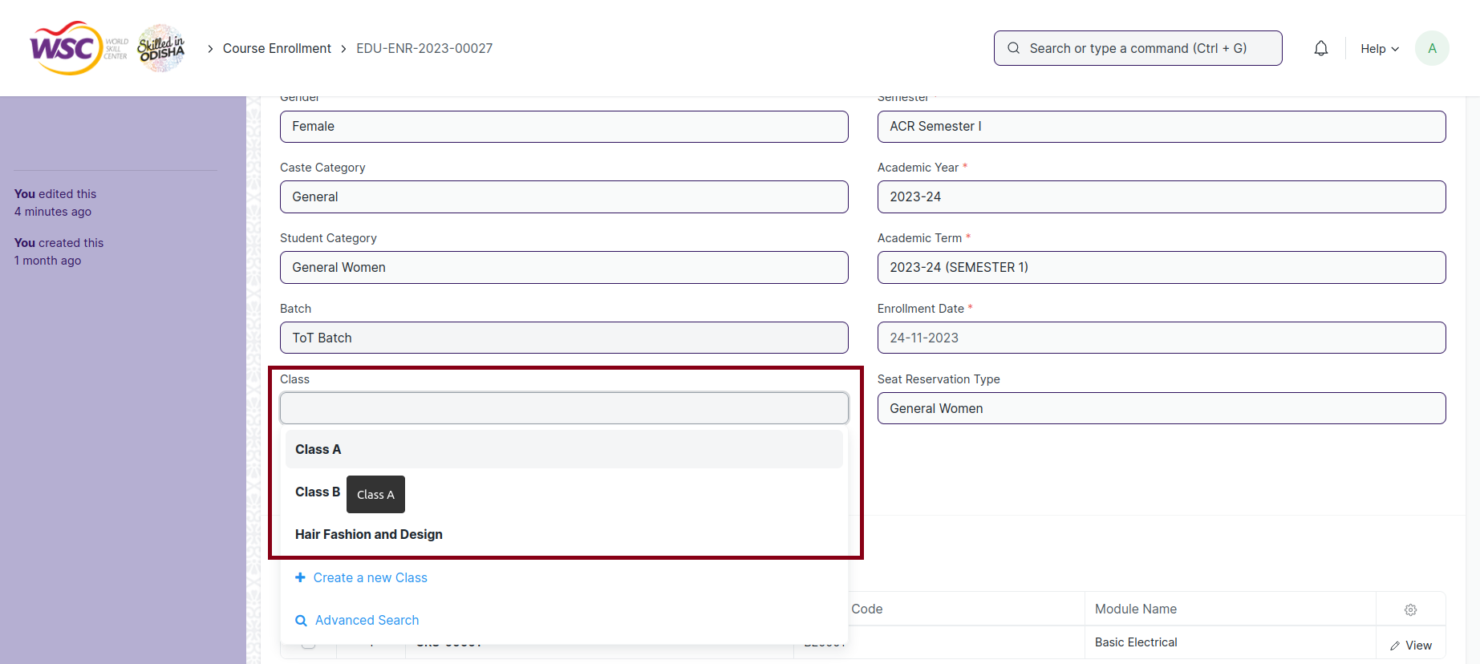

Step 5. Update/Add Batch in the Batch field

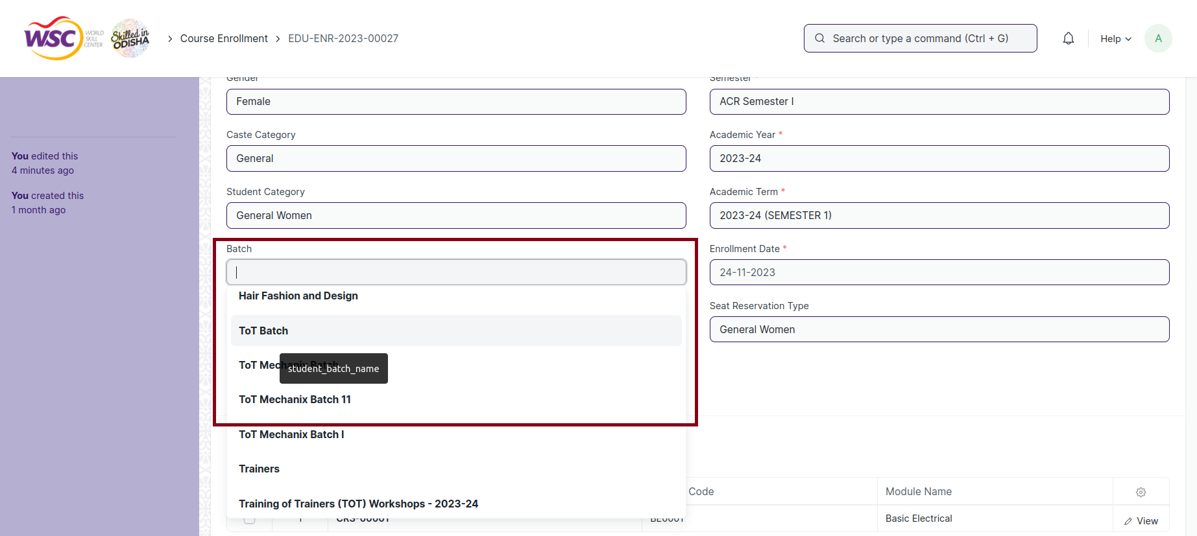

Step 3. Click on Update button

